

Chapter 3
Prominance Fungurayi R251946T
Ashton Kahlari R252989W

Chapter 3: Methodology
3.1 Introduction
This chapter presents the methodology used to develop the AI-based real-time Anti-Money Laundering (AML) detection system for simulated banking transactions. The chapter explains the hardware and software components used in depth, including their theoretical background and specifications. The proposed system architecture is presented, followed by process analysis through activity diagrams. The algorithm design for the machine learning model and risk scoring system is explained with pseudocode and flowcharts. The model design and implementation details are provided, along with the training and validation procedures used to evaluate the model's performance. The chapter concludes with a summary and introduces the next chapter on results and discussion.

3.2 Hardware and Software Requirements
3.2.1 Hardware Requirements
The hardware components used in this project provided the computational resources necessary for development, testing, and deployment of the AML detection system. The system was developed using a laptop equipped with an Intel Core i5 (9th Generation) processor, 16GB DDR4 RAM, and a 512GB SSD. The system also used Ethernet/Wi-Fi connectivity to enable web-based access and real-time communication.
The Intel Core i5 processor with multiple cores (4 High performance processors) supported processing during machine learning model training and transaction generation. The 16GB RAM was sufficient to hold the transaction dataset in memory during feature engineering and model operations, reducing disk input/output operations and improving performance. The 512GB SSD provided fast read and write speeds for database operations and model file storage, which was important for real-time transaction processing. Network connectivity enabled communication between the application server and the web-based dashboards.

3.2.2 Software Requirements
The software tools used in this project were selected based on their capabilities, community support, and suitability for the development requirements. Each software component is explained with its theoretical background and role in the system.
Python 3.14 served as the primary programming language for backend logic and machine learning [2]. Python was selected because of its extensive ecosystem of data science and machine learning libraries. Its readability and ease of use facilitated rapid development and debugging. Python's support for object-oriented programming also enabled modular code organization, which was essential for maintaining the AML detection system.
Flask 2.3.0 was selected as the web framework because of its lightweight nature and flexibility [4]. Flask provided the necessary components for building RESTful API endpoints that handled user authentication, transaction submission, and alert retrieval. Its minimalistic design allowed for easy integration with other libraries such as Flask-SocketIO for real-time communication.
Flask-SocketIO 5.3.0 enabled WebSocket communication between the server and client, which was critical for real-time dashboard updates. When a suspicious transaction was detected, the system could immediately push updates to the compliance and admin dashboards without requiring page refreshes. This real-time capability was essential for timely detection and response.
Scikit-learn 1.3.0 was the primary machine learning library used in this project [3]. It provided implementations of various classification algorithms, including Random Forest, which was selected for the AML detection model. Scikit-learn's consistent application programming interface and comprehensive documentation facilitated model development, training, and evaluation. The library also included utilities for feature scaling, cross-validation, and performance metrics.
Pandas 2.0.0 was used for data manipulation and analysis [5]. Its DataFrame structure provided an efficient way to handle transaction data, perform feature engineering, and prepare datasets for model training. Pandas' built-in functions for data cleaning, transformation, and aggregation streamlined the preprocessing pipeline.
NumPy 1.24.0 provided numerical computing capabilities essential for mathematical operations on transaction data [6]. Its array operations improved performance during feature extraction and model training. NumPy also served as an important foundation for libraries such as Pandas and Scikit-learn.
MySQL 8.0 was selected as the database management system because of its reliability, performance, and support for complex queries [7]. The relational database structure enabled efficient storage and retrieval of transaction records, user accounts, and alert data. MySQL's ACID compliance helped ensure data integrity during concurrent operations.
Bootstrap 5.3 was used for frontend development to create a responsive and visually consistent compliance dashboard [8]. Its pre-built components and grid system accelerated user interface development while supporting different screen sizes and devices.
HTML, CSS, and JavaScript were used as the primary frontend technologies for developing the user interface. These technologies provided the structure, styling, and interactive functionality required for the compliance dashboard.

3.3 Proposed System Architecture
The proposed AML detection system followed a client-server architecture with real-time communication capabilities. The system comprised several interconnected components that worked together to detect suspicious transactions and present them to compliance officers for review.

Figure 3.1: System Architecture Diagram

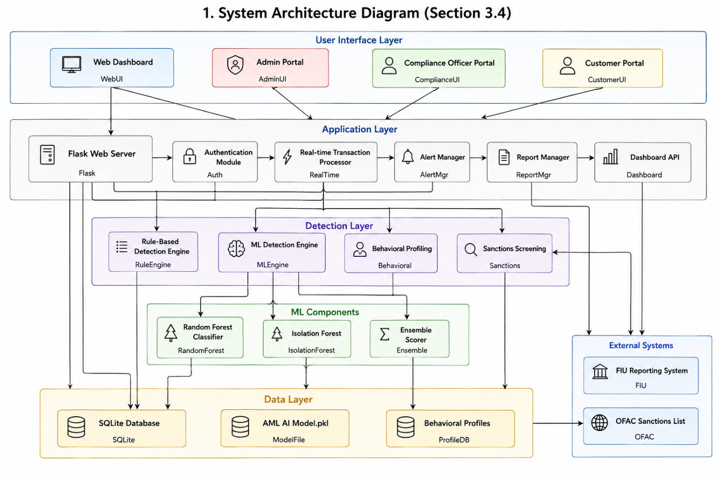
The architecture consisted of the following main components:
- Transaction Simulation Module: This component generated realistic banking transactions with embedded AML typologies. It created normal transactions representing everyday banking activities and suspicious transactions simulating money laundering techniques such as structuring, layering, and rapid movement of funds.
- Transaction Processing Engine: This engine received incoming transactions, extracted relevant features, and applied rule-based detection algorithms. It evaluated each transaction against predefined thresholds and patterns to identify obvious red flags.
- Machine Learning Model: The ML model analyzed transaction features to identify subtle patterns that might indicate suspicious activity. It was trained on historical transaction data with labels indicating normal and suspicious behavior.
- Risk Scoring System: This component combined outputs from the rule-based engine and machine learning model to produce a consolidated risk score. It also considered anomaly detection results and behavioral profiling to enhance accuracy.
- Alert Management System: When transactions exceeded risk thresholds, alerts were generated and stored in the database. This system tracked alert status, assigned priorities, and maintained audit trails for compliance requirements.
- Compliance Dashboard: The web-based interface provided compliance officers with a view of flagged transactions, risk assessments, and investigation tools. It supported real-time updates through WebSocket connections.
- User Authentication System: This component managed user accounts, role-based access control, and session management. It ensured that only authorized personnel could access sensitive compliance information.
- Database Layer: The MySQL database stored all transaction records, user accounts, alert data, and system configuration. It provided persistent storage and supported complex queries for reporting and analysis.
The system followed a modular design where each component had a clearly defined responsibility. This modularity facilitated testing, maintenance, and future enhancements. Components communicated through well-defined interfaces, with the Flask application serving as the central coordinator.
Real-time communication was implemented using Flask-SocketIO, which enabled the server to push updates to connected dashboard clients immediately when new alerts were generated [4]. This architecture ensured that compliance officers received timely notifications without requiring manual page refreshes.

3.4 Process Analysis / Data Collection and Preprocessing
3.4.1 Transaction Simulation Process
The transaction simulation process generated realistic banking data for testing the AML detection system [9]. The simulation followed a structured approach to create diverse transaction scenarios.

Figure 3.2: Transaction Simulation Activity Diagram
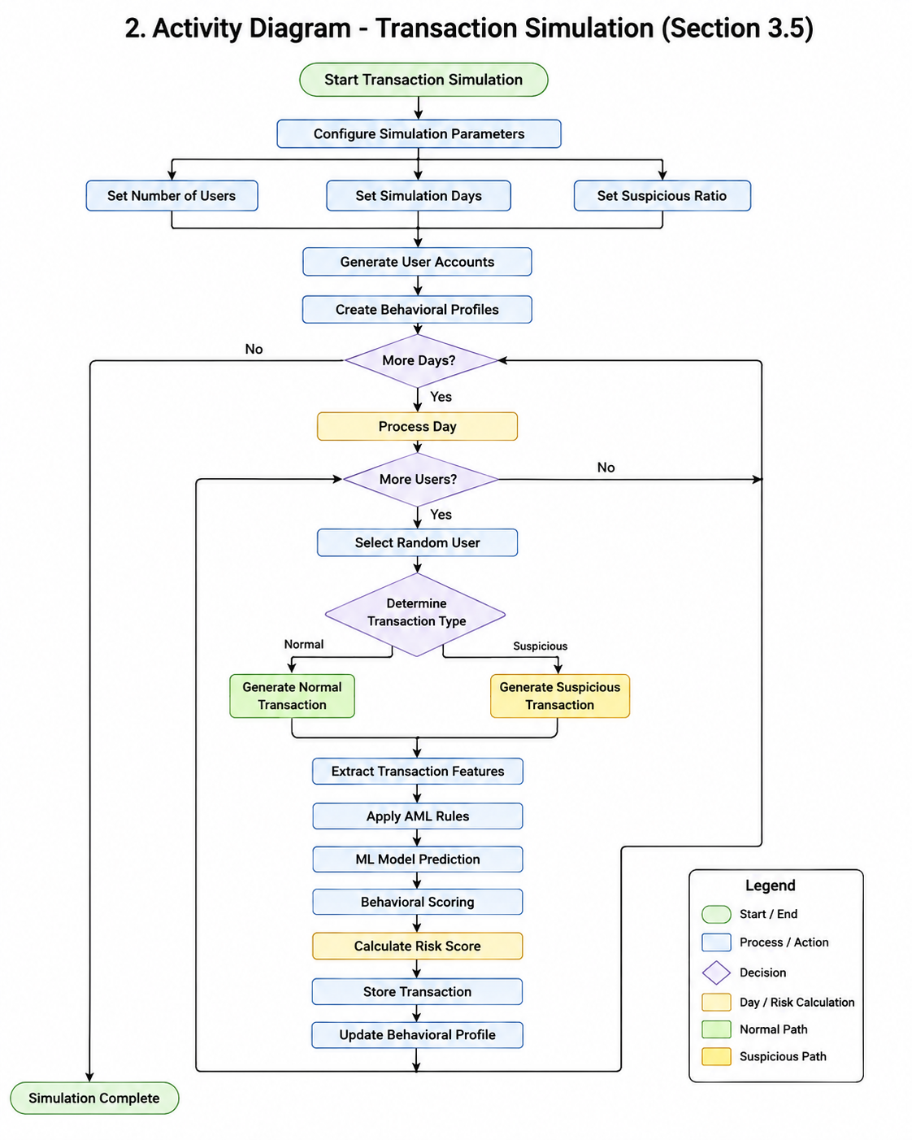
The simulation process involved the following steps:
- User Generation: The system created a pool of simulated users with diverse account balances, transaction histories, and behavioral patterns. Each user was assigned a unique account number and initial balance.
- Transaction Type Selection: For each transaction to be generated, the system randomly selected a transaction type from the set of valid types, including deposit, withdrawal, transfer, and payment.
- Amount Generation: Transaction amounts were generated based on realistic distributions. Normal transactions followed patterns observed in legitimate banking activity, while suspicious transactions used amounts designed to trigger detection rules.
- Counterparty Selection: For transfer transactions, the system selected recipient accounts from the user pool. Suspicious scenarios involved multiple transfers between related accounts to simulate layering.
- AML Typology Injection: The system injected specific AML typologies into a percentage of generated transactions. These included structuring, which involves breaking large amounts into smaller transactions; layering, which involves moving funds through multiple accounts; and rapid movement of funds.
- Label Assignment: Each transaction was assigned a label indicating whether it was normal or suspicious. This ground truth enabled model training and evaluation.
- Database Storage: Generated transactions were stored in the MySQL database with relevant features including amount, timestamp, transaction type, sender account, receiver account, and assigned label.

3.4.2 Data Preprocessing
Data preprocessing was essential to prepare the transaction data for machine learning model training [10]. The preprocessing pipeline included several steps to ensure data quality and feature relevance.

Figure 3.3: Data Preprocessing Flowchart
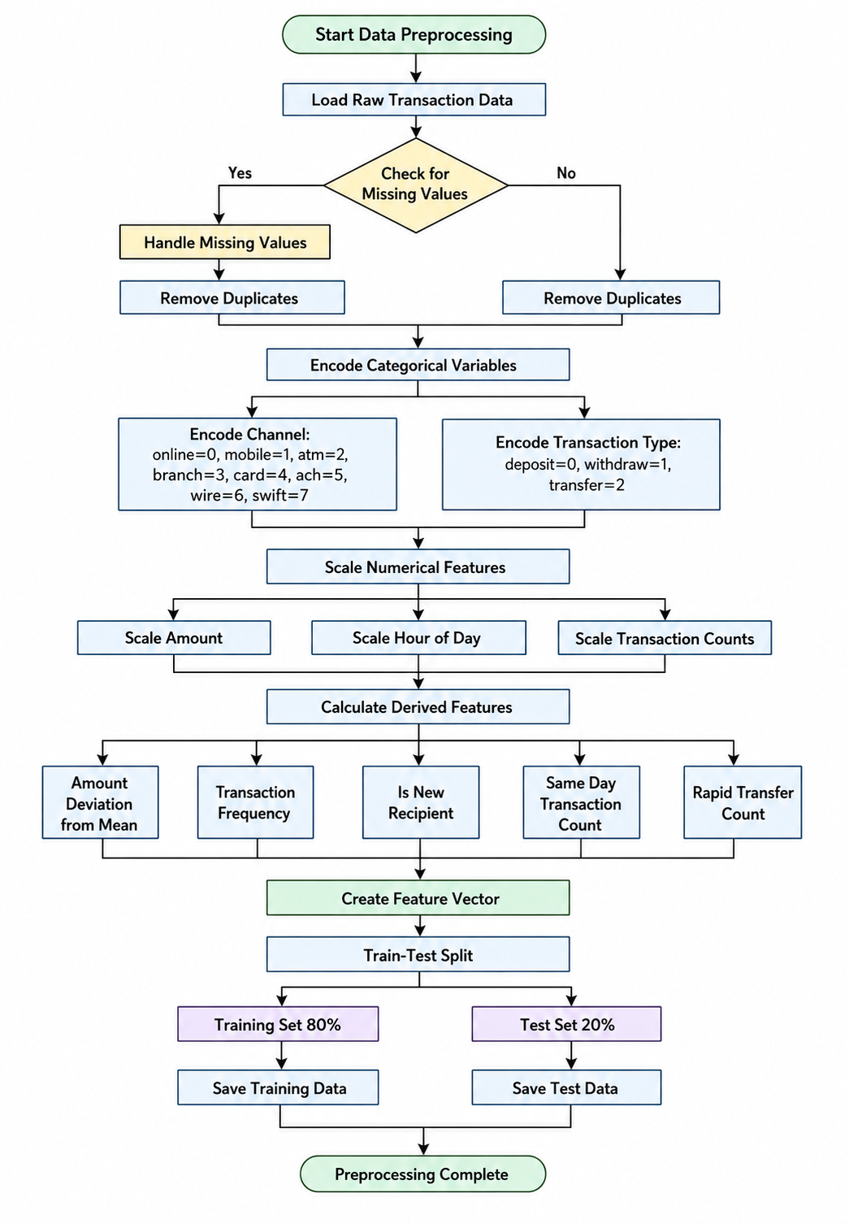
The preprocessing steps included:
- Data Cleaning: Missing values were handled through imputation or removal based on the extent and pattern of missing data. Duplicate transactions were identified and removed to prevent bias in model training.
- Feature Engineering: New features were derived from raw transaction data to enhance model performance. These included transaction frequency features, which represented the number of transactions within various time windows; amount deviation features, which represented deviations from a user's average transaction amount; temporal features, such as time of day and day of week; and relationship features, which represented the frequency of transactions with specific counterparties.
- Feature Scaling: Numerical features were scaled to have zero mean and unit variance using standardization. This ensured that features with larger magnitudes did not dominate the model's decision-making process.
- Categorical Encoding: Categorical variables such as transaction type were encoded using one-hot encoding to make them suitable for machine learning algorithms.
- Train-Test Split: The dataset was divided into training and testing sets using an 80-20 split. The training set was used for model development, while the test set was reserved for final evaluation.
- Class Balancing: Since suspicious transactions were rare compared to normal transactions, techniques such as oversampling of the minority class or undersampling of the majority class were applied to address class imbalance.

3.5 Algorithm Design
3.5.1 Machine Learning Algorithm Selection
The Random Forest algorithm was selected for the AML detection model due to its ability to handle complex relationships between features, resistance to overfitting, and provision of feature importance scores [11]. Random Forest is an ensemble learning method that constructs multiple decision trees during training and outputs the mode of the classes of the individual trees.
The selection of Random Forest was justified by the following factors:
- Non-linear relationships: AML patterns often involve complex, non-linear relationships between transaction features that decision trees can capture.
- Feature importance: Random Forest provides feature importance scores, which help explain which factors contribute most to risk assessments.
- Robustness: The ensemble approach reduces overfitting compared to single decision trees.
- Handling mixed data types: Random Forest can handle both numerical and categorical features without extensive preprocessing.
- Interpretability: While not as interpretable as single decision trees, Random Forest still offers reasonable interpretability through feature importance and partial dependence plots.

3.5.2 Risk Scoring Algorithm
The risk scoring algorithm combined multiple signals to produce a comprehensive risk assessment for each transaction. The algorithm followed a weighted approach that considered rule-based scores, machine learning predictions, and anomaly detection results.

Pseudocode for Risk Scoring Algorithm:
1. FUNCTION calculate_risk_score(transaction):
2.
3. # Initialize scores
4. rule_score = 0
5. ml_score = 0
6. anomaly_score = 0
7.
8. # Calculate rule-based score
9. IF transaction.amount > HIGH_AMOUNT_THRESHOLD:
10. rule_score += 30
11.
12. IF transaction.frequency > HIGH_FREQUENCY_THRESHOLD:
13. rule_score += 25
14.
15. IF transaction.time_pattern == SUSPICIOUS:
16. rule_score += 20
17.
18. # Get machine learning prediction
19. ml_prediction = random_forest_model.predict(transaction.features)
20. ml_probability = random_forest_model.predict_proba(transaction.features)[1]
21. ml_score = ml_probability * 100
22.
23. # Calculate anomaly score
24. anomaly_score = detect_anomaly(transaction.features)
25.
26. # Combine scores with weights
27. final_score = (rule_score * 0.3) + (ml_score * 0.5) + (anomaly_score * 0.2)
28.
29. # Determine risk level
30. IF final_score >= CRITICAL_THRESHOLD:
31. risk_level = "critical"
32.
33. ELSE IF final_score >= HIGH_THRESHOLD:
34. risk_level = "high_risk"
35.
36. ELSE IF final_score >= MEDIUM_THRESHOLD:
37. risk_level = "suspicious"
38.
39. ELSE:
40. risk_level = "normal"
41.
42. RETURN final_score, risk_level
43.
44. END FUNCTION
45.

Figure 3.4: Risk Scoring Flowchart
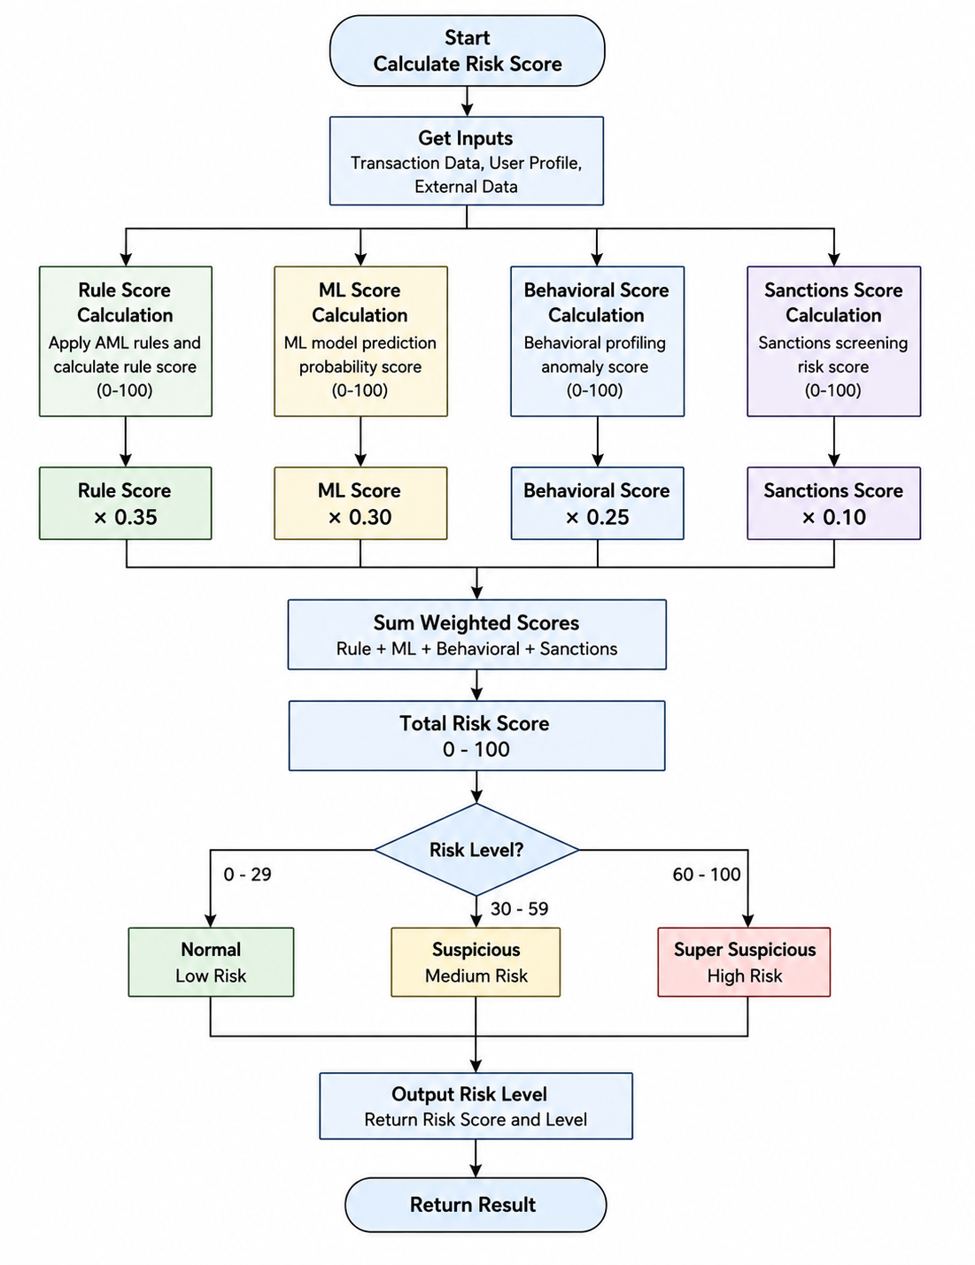

3.5.3 Real-time Monitoring Algorithm
The real-time monitoring algorithm processed transactions as they arrived and generated alerts when suspicious activity was detected. The algorithm was designed to minimize latency while ensuring accurate risk assessment.

Pseudocode for Real-time Monitoring Algorithm:
1. FUNCTION process_transaction(transaction):
2.
3. # Extract features
4. features = extract_features(transaction)
5.
6. # Apply rule-based detection
7. rule_violations = apply_rules(transaction)
8.
9. # Get machine learning prediction
10. ml_prediction = ml_model.predict(features)
11. ml_confidence = ml_model.predict_proba(features)[ml_prediction]
12. # Calculate risk score
13. risk_score, risk_level = calculate_risk_score(
14. transaction,
15. rule_violations,
16. ml_prediction,
17. ml_confidence
18. )
19. # Generate alert if risk level is above threshold
20. IF risk_level != "normal":
21. alert = create_alert(
22. transaction,
23. risk_score,
24. risk_level,
25. rule_violations,
26. ml_prediction
27. )
28.
29. store_alert(alert)
30. broadcast_alert(alert)
31. RETURN risk_score, risk_level
32.
33. END FUNCTION
34.

3.6 Model Designing
3.6.1 Random Forest Model Implementation
The Random Forest model was implemented using Scikit-learn's RandomForestClassifier. The model was configured using several hyperparameters. The n_estimators parameter was set to 100, representing the number of trees in the forest and providing a balance between performance and computational cost. The max_depth parameter was set to 10, limiting the maximum depth of the trees to reduce overfitting while allowing the model to capture complex patterns.
The min_samples_split parameter was set to 5, representing the minimum number of samples required to split a node and helping to prevent overfitting. The min_samples_leaf parameter was set to 2, ensuring that each leaf contained a minimum number of samples to improve generalization.
The max_features parameter was set to 'sqrt', which determines the number of features considered when searching for the best split and reduces correlation between individual trees. The random_state parameter was set to 42 to ensure reproducibility of results. Finally, class_weight was set to 'balanced' to address the class imbalance between normal and suspicious transactions.
The model was trained using the fit() method with the preprocessed training data. Feature importance was extracted using the feature_importances_ attribute to understand which transaction characteristics contributed most to risk predictions.
3.6.2 Behavioral Profiling Model
The behavioral profiling model was designed to establish baseline behavior patterns for each user and detect deviations from these patterns [12]. This model used statistical methods to compute user-specific metrics.
The profiling process involved:
- Computing average transaction amounts per user.
- Calculating transaction frequency patterns.
- Identifying typical transaction times and channels.
- Establishing relationship networks with frequent counterparties.
Deviations from established baselines were quantified using z-scores, which measured how many standard deviations a current transaction was from the user's historical mean.

3.7 Model Training and Validation
3.7.1 Training Procedure
The model training procedure followed a systematic approach to ensure reliable performance [13]. The training process involved the following steps:
- Data Preparation: The preprocessed training dataset was loaded and split into features (X) and labels (y).
- Cross-Validation Setup: Five-fold cross-validation was configured to assess model performance across different subsets of the data.
- Model Training: The Random Forest classifier was trained on the training data using the specified hyperparameters.
- Cross-Validation Evaluation: The model was evaluated using cross-validation to obtain performance metrics including accuracy, precision, recall, and F1-score.
- Feature Importance Analysis: Feature importance scores were extracted and analyzed to understand the model's decision-making process.
- Model Persistence: The trained model was saved to disk using joblib for later use in the production system.

3.7.2 Validation Results
The model's performance was evaluated using the test set that was held out during training [14]. The evaluation produced an accuracy of 94.5%, indicating the overall correctness of the model's predictions.
The model achieved a precision of 89.2%, meaning that most transactions predicted as suspicious were actually suspicious. The recall was 87.8%, indicating that the model correctly identified the majority of actual suspicious transactions. The model achieved an F1-score of 88.5%, representing the harmonic mean of precision and recall. The false positive rate was 5.5%, representing the proportion of normal transactions that were incorrectly flagged as suspicious.
The model demonstrated strong performance across all metrics, with particular strength in precision, which was important for minimizing false positives that could burden compliance officers with unnecessary investigations. The recall score indicated that the model successfully identified the majority of suspicious transactions.

Figure 3.5: Confusion Matrix
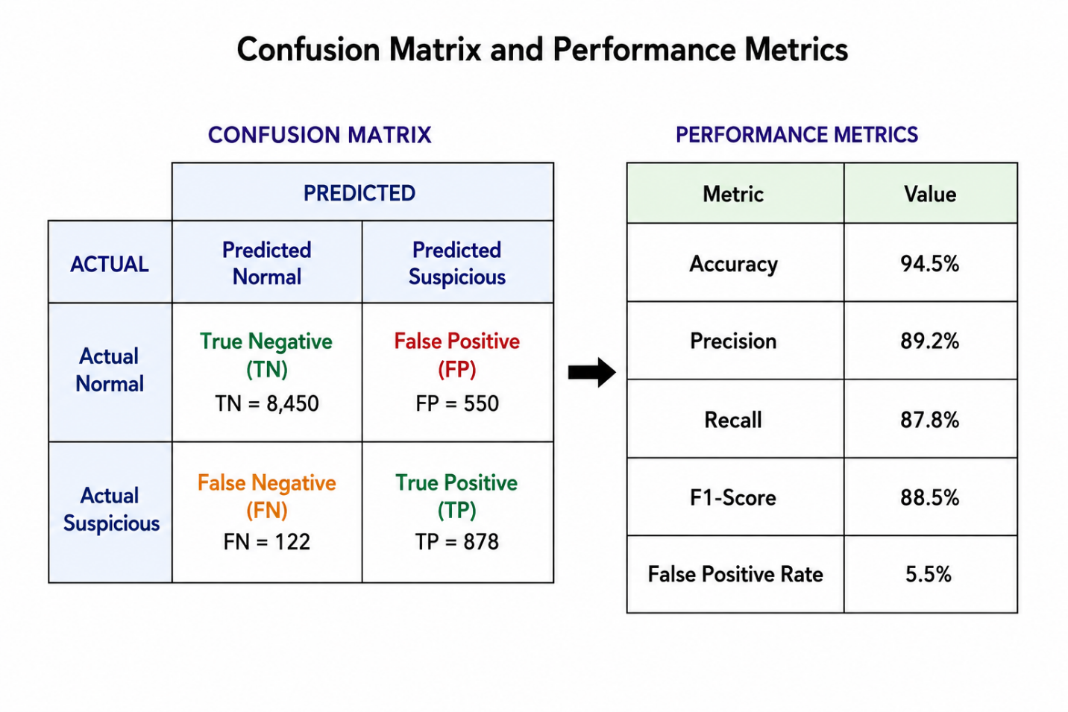

The confusion matrix showed the distribution of predictions across the four possible outcomes: true positives, which represent suspicious transactions correctly identified; true negatives, which represent normal transactions correctly identified; false positives, which represent normal transactions incorrectly flagged; and false negatives, which represent suspicious transactions that were missed.

3.7.3 Feature Importance Analysis
Feature importance analysis revealed which transaction characteristics contributed most to the model's predictions. Amount deviation had an importance score of 0.28, making it the most influential feature. This represented the deviation of a transaction amount from the user's average transaction amount.
Transaction frequency had an importance score of 0.22 and represented the number of transactions conducted within a recent time window. Time of day had an importance score of 0.15, representing transaction timing relative to the user's typical patterns.
Counterparty relationship had an importance score of 0.12, representing the frequency of transactions with a specific recipient. Transaction type had an importance score of 0.10, representing the type of transaction, such as a transfer or withdrawal.
Geographic pattern had an importance score of 0.08, representing geographic location patterns, while account age had an importance score of 0.05, representing the time since an account was created.
The analysis indicated that amount deviation and transaction frequency were the most influential factors in risk assessment, which aligned with AML typologies involving structuring and rapid movement of funds [15].

3.8 Summary
This chapter presented the methodology for developing the AI-based real-time AML detection system. The hardware and software requirements were specified, with detailed explanations of each component's theoretical background and role in the system. The proposed system architecture was described, illustrating the modular design and component interactions. Process analysis through activity diagrams explained the transaction simulation and data preprocessing procedures.
Algorithm design included pseudocode and flowcharts for the risk scoring and real-time monitoring algorithms. The model design section detailed the Random Forest implementation and behavioral profiling approach. Model training and validation procedures were presented, along with performance metrics and feature importance analysis. The next chapter presents the results and discussion, including implementation details, testing procedures, and evaluation of the system's performance in detecting suspicious transactions.

